- Week of : August 24, 2020 | Grade Level: Kindergarten
PYP Unit and Central Idea: Who We Are- Roles and responsibilities help us make connections.
Prioritized Standards Addressed This Week:
Math MGSEK.G.1 Describe objects in the environment using names of shapes, and describe the relative positions of these objects using terms such as above, below, beside, in front of, behind, and next to. MGSEK.G. 4 Analyze and compare two- and three-dimensional shapes, in different sizes and orientations, using informal language to describe their similarities, differences, parts (e.g., number of sides and vertices/“corners”) and other attributes (e.g., having sides of equal length).
Reading/ ELA ELAGSEKRL10: ELAGSEKRF3: Know and apply grade-level phonics and word analysis skills in decoding words. ELAGSEKRL1: With prompting and support, ask and answer questions about key details in a text

Science/ Social Studies SSKCG1 The student will demonstrate an understanding of good citizenship. SSKE1 Describe the work that people do such as: police officer, fire fighter, soldier, mail carrier, farmer, doctor, teacher, etc.

Asterisk & Highlighted items will be graded
Lessons Highlighted in blue will be Synchronous Lessons (Live in Teams) Synchronous – Live
Asynchronous – Not live

 | MONDAY | TUESDAY | WEDNESDAY | THURSDAY | FRIDAY

Student Login/  Morning Meeting (SEL)  8:15 a.m. | Focus Lessons:  Live Class- Share Screen  Heards Ferry Live  SEL- Emotions  How Are You? Video and Discuss | Focus Lessons  Live Class- Share Screen  Heards Ferry Live  SEL-Emotions  How Are You? Activity | Focus Lessons  Live Class- Share Screen  Heards Ferry Live  Morning Meeting | Focus Lessons  Live Class- Share Screen  Heards Ferry Live  Morning Meeting | Focus Lessons  Live Class- Share Screen  Heards Ferry Live  Morning Meeting
Math  8:30 a.m. | Live Class- Share Screen  Learning about 2D Shapes Video  Live Read Aloud of “Shaping Up” | Live Class- Share Screen  Learning about Positional Words Video  Live Read Aloud of “Go Pete Go” | Live Class- Share Screen  Learning about 2D Shapes Video  Live Read Aloud of “From Circles to Cubes” | Live Class- Share Screen  Learning about 2D Shapes Sides and Corners Videos  Activity- Comparing shapes around us | Live Class- Share Screen  Learning about 2D Shapes Video  Live Read Aloud of “Shaping Up”
 | Student Independent Practice  In Seesaw, find the activity below. Watch the instructional video and complete the assignment.  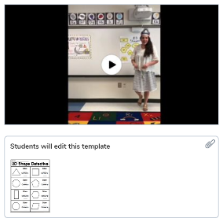 | Student Independent Practice  In Seesaw, find the activity below. Watch the instructional video and complete the assignment.  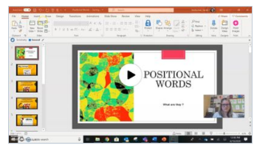  *W.A. goes to OT | Student Independent Practice  In Seesaw, find the activity below. Watch the instructional video and complete the assignment.  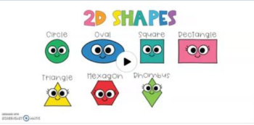 | Student Independent Practice  Comparing 2d shapes sides and corners- seesaw activity video and seesaw activity | Student Independent Practice  Comparing 2d shapes sides and corners video and seesaw activity  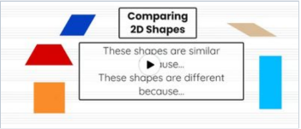
Specials  9:00am | Live Class- Share Screen  Art with Ms. Rizzo | Live Class- Share Screen  Music with Ms. LeSaicherre | Live Class- Share Screen  PE with Ms. Karatassos | Live Class- Share Screen  Art with Ms. Katie | Live Class- Share Screen  Music with Mr. Kevin
Reading/ELA  10:00 a.m. | Live Class- Share Screen  Letter C Video  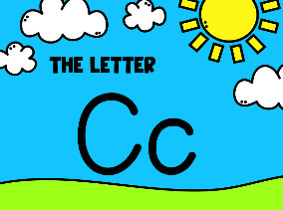  Read Aloud: Letter C | Live Class- Share Screen  Read Aloud- Knuffle Bunny  *A.C-R in Speech | Live Class- Share Screen  Letter O Video  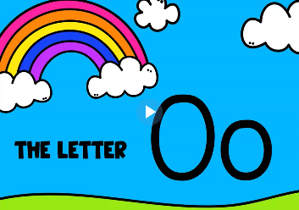  Read Aloud: Letter O | Live Class- Share Screen  Read Aloud Video- Silly Sally | Live Class- Share Screen  Letter O Video  Read Aloud: Letter O
 | Student Independent Practice  SeeSaw Activities:  - Practice writing the letter C  - Complete All About Me Activity | Student Independent Practice  Reading  SeeSaw Activity  - Knuffle Bunny Activity  Phonics  Login to iReady Reading through Classlink and work for 15 minutes on Reading. | Student Independent Practice  SeeSaw Activities:  - Practice writing the letter O | Student Independent Practice  SeeSaw Activity  - Silly Sally  Phonics  Login to iReady Reading through Classlink and work for 15 minutes on Reading. | Student Independent Practice  SeeSaw Activities:  - Practice writing the letter O
Social Studies /Science  10:45 a.m. | Focused Lesson  Live – Screen share read aloud - Epic Books: I am a Good Citizen  Discuss as a class. | Focused Lesson  Live – Screen Share “Do Unto Otters “animated YouTube video:  Discuss as a class. | Focused Lesson  Live -Good Citizen Or Not?  Teacher will read scenarios and students will draw a happy face if it is being a good citizen and a sad face if it is not being a good citizen. | Focused Lesson  Live Problem and Solution  Read Aloud of “Big Bird Can Share”  Discuss how we share with friends. | Focused Lesson  Live - Teacher will explain the class wonder wall and that we inquire about the world around us as it relates to our current IB Unit.  Teacher will model her wonder.
 | Student Independent Practice  SeeSaw-  Circle which pictures are examples of being a good citizen | Student Independent Practice  See Saw-  Draw a picture of how you have been a good friend. | Student Independent Practice  See Saw-  Draw a picture of how you can be a good citizen. | Student Independent Practice  See Saw- Sharing activity | Student Independent Practice  SeeSaw- Write out things we wonder about. These will be printed and posted on our classroom wall.
Independent Work Time  12:00-12:45 | One on one Meetings with students.  William- Ms. Northcut  Thiago- Ms. Hendrix  Heidi- Ms. Beindorf | One on one Meetings with students.  Jonathan- Ms. Northcut  Myla- Ms. Hendrix  Aaron- Ms. Beindorf  *A.V. and T.P-A in Speech from 12:30-1 w/Rosenfield | One on one Meetings with students.  Thiago- Ms. Northcut  Aaron- Ms. Hendrix  Azael- Ms. Beindorf  * J.L. and M.M in Speech from 12:15-12:45 w/North | One on one Meetings with students.  Heidi- Ms. Northcut  William- Ms. Hendrix  Myla- Ms. Beindorf  *A.V. and T.P-A in Speech from 12:30-1 | One on one Meetings with students.  Azael- Ms. Northcut  Heidi- Ms. Hendrix  Thiago- Ms. Beindorf
Independent Work Time  12:45- 2:00 | One on one Meetings with students.  Myla- Ms. Northcut  Azael- Ms. Hendrix | Independent work for whole class.  *H.K. and W.A. in Speech from 1-1:30 w/Beacham | Independent work for whole class.  *H.K. and W.A. in Speech from 1-1:30 w/Beacham | One on one Meetings with students.  Aaron- Ms. Northcut  Jonathan- Ms. Hendrix | Independent work for whole class.
Independent Work Time  2:00-3:00 | One on one Meetings with students.  Jonathan- Ms. Beindorf | Independent work for whole class. | Independent work for whole class. | Independent work for whole class. | One on one Meetings with students.  William- Ms. Beindorf
Due Dates | All Independent practice activities will be due Friday September 11, 2020. | All Independent practice activities will be due Friday September 11, 2020. | All Independent practice activities will be due Friday September 11, 2020. | All Independent practice activities will be due Friday September 11, 2020. | All Independent practice activities will be due Friday September 11, 2020.

