Week of: January 11th | Grade Level: Kindergarten
PYP Unit and Central Idea: IB Unit 4: How the World Works; Senses Help Us Investigate Our World
Math Standards MGSEK.CC.1 Count to 100 by ones and by tens.
MGSEK.CC.5 Count to answer “how many?” questions.
MGSEK.CC.6 Identify whether the number of objects in one group is greater than, less than, or equal to the number of objects in another group, e.g., by using matching and counting strategies.
MGSEK.CC.7 Compare two numbers between 1 and 10 presented as written numerals.
MGSEK.NBT.1 Compose and decompose numbers from 11 to 19 into ten ones and some further ones to understand that these numbers are composed of ten ones and one, two, three, four, five, six, seven, eight, or nine ones, e.g., by using objects or drawings, and record each composition or decomposition by a drawing or equation (e.g., 18 = 10 + 8).
MGSE1.NBT.7 Identify dimes and understand ten pennies can be thought of as a dime. (Use dimes as manipulatives in multiple mathematical contexts.)
MGSEK.MD.3 Classify objects into given categories; count the numbers of objects in each category and sort the categories by count.

Reading/ ELA ELAGSEKRL10: ELAGSEKRF3: Know and apply grade-level phonics and word analysis skills in decoding words. ELAGSEKRL1: With prompting and support, ask and answer questions about key details in a text
Science/ Social Studies SSKG2 Explain that a map is a drawing of a place and a globe is a model of Earth.
a. Differentiate land and water features on simple maps and globes.
b. Explain that maps and globes show a view from above.
c. Explain that maps and globes show features in a smaller size.
SSKG3 State the street address, city, state, and country in which the student lives.
Asterisk & Highlighted items will be graded
Lessons Highlighted in blue will be Synchronous Lessons (Live in Teams)
Synchronous – Live Asynchronous – Not live

 | Monday | Tuesday | Wednesday | Thursday | Friday
Student Login/Morning Meeting  8:10am | Focus Lessons  Synchronous- Share Screen  Heards Ferry Live  Morning Meeting | Focus Lessons  Synchronous- Share Screen  Heards Ferry Live  Morning Meeting | Focus Lessons  Synchronous- Share Screen  Heards Ferry Live  Morning Meeting | Focus Lessons  Synchronous- Share Screen  Heards Ferry Live  Morning Meeting | Focus Lessons  Synchronous- Share Screen  Heards Ferry Live  Morning Meeting
Math  8:10am – 9:20am | Synchronous- Share Screen  Hook:  Jack Hartmann – Teen Number Bonds  https://www.youtube.com/watch?v=MmLMU8BqyKw  Mini Lesson:  Students will model base 10 using dimes and pennies. They will mutiple examples  See column on the left for your student’s small group time to be on Teams.  Independent Work:  Students will complete the following activity on seesaw  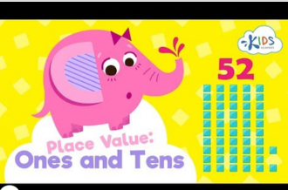 | Synchronous- Share Screen  Harry Kindergarten: Numbers in the Teens  https://www.youtube.com/watch?v=1W5aYi3lkho  Mini Lesson:  Continue mini lesson from previous day.  See column on the left for your student’s small group time to be on Teams.  Independent Work:  Students will complete the following activity on seesaw  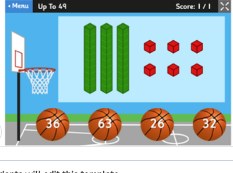 | Synchronous- Share Screen  Review Chant  Hook:  Chant- (to the tune of I’ve been told army chant)  - I don’t know what I’ve been told (repeat)  - Tens are tall and ones are small (repeat)  - First you count up all the tens (repeat)  - And then the babies at the end  - Sound on (1,2)  - Sound off 3,4)  - 1,2,3,4  Mini Lesson:  Review listing the tens spot before the ones spot  See column on the left for your student’s small group time to be on Teams.  Independent Work:  Students will complete the following activity on seesaw  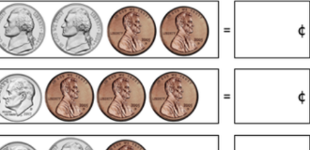 | Synchronous- Share Screen  Hook- https://www.ixl.com/math/kindergarten/count-tens-and-ones-up-to-30  Mini-Lesson-  Could you show it in ten frames? Write an equation? Etc.  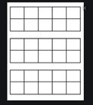  See column on the left for your student’s small group time to be on Teams.  Independent Work:  Students will complete the following activity on seesaw  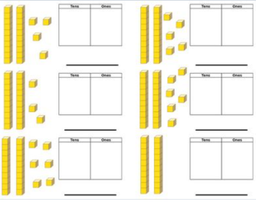  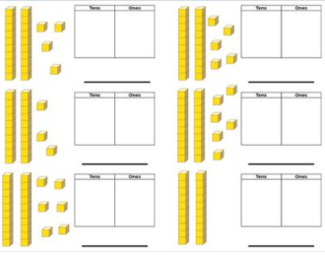 | Synchronous- Share Screen  Hook- https://www.youtube.com/watch?v=MmLMU8BqyKw  Mini Lesson-Review of coins  Could you show it in ten frames? Write an equation? Etc.  See column on the left for your student’s small group time to be on Teams.  Independent Work:  Students will complete the following activity on seesaw  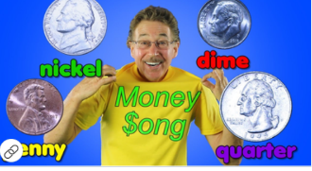
Group 1 – 8:35-8:50
Group 2 – 8:50-9:05
Group 3 – 9:05-9:20
Shared Reading  9:20am – 9:35am | Synchronous- Share Screen  Epic! Books  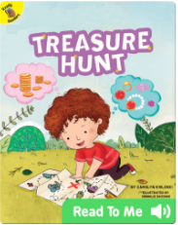 | Synchronous- Share Screen  Epic! Books  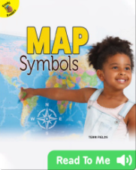 | Synchronous- Share Screen  Epic! Books  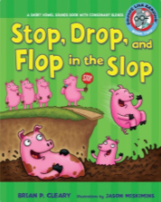 | Synchronous- Share Screen  Epic! Books | Synchronous- Share Screen  Epic! Books  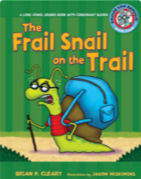
Phonics  9:35am- 9:50am | Synchronous- Share Screen  On Seesaw, find the assignment below:  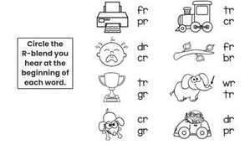Circle the correct R blend at the beginning of each picture. | Synchronous- Share Screen  On Seesaw, find the assignment below:  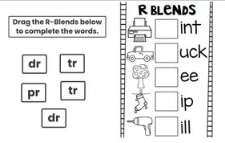Drag the r-blends to complete the words. | Synchronous- Share Screen  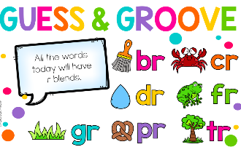  No Seesaw assignment  Just have paper and pencil ready! | Synchronous- Share Screen  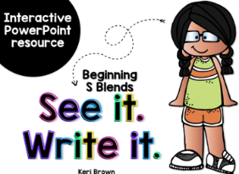  No Seesaw assignment  Just have paper and pencil ready! | Synchronous- Share Screen  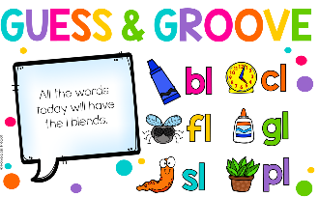  No Seesaw assignment  Just have paper and pencil ready!
Read Aloud  10:30am – 10:45 | Synchronous- Share Screen | Synchronous- Share Screen | Synchronous- Share Screen | Synchronous- Share Screen | Synchronous- Share Screen
Writer’s Workshop  10:45am – 11:30am | Synchronous- Share Screen  Unit 2, Session 10: Using Reading Partnerships to Support More Conventional Writing  After watching the video, students will meet with a partner about their writing. Then, they will take their partner’s suggestions and continue working on their true story books. | Synchronous- Share Screen  Unit 2, Session 11: Letter to Teachers: Using a Partner to Hear More Sounds in Words  After watching the video, students will meet again with their writing partner and read each other’s work. Then, they will continue working on their true story books. | Synchronous- Share Screen  Unit 2, Session 12: Putting It Together: How to Make Readable Writing  After watching the video, students will work on editing and adding to their work to make it better. | Synchronous- Share Screen  Unit 2, Session 13: Writers Search Their Mental and Drawn Pictures to Make Their Stories Better  After watching the video, students will continue working on their true story writing. | Synchronous- Share Screen  Review lessons  Review the “True Story Writing” and “Making Writing Easy to Read” charts with students.  Students will continue working on their writing and meeting with partners as necessary.
Social Studies/Science  11:30am – 12:00pm | Synchronous- Share Screen  Hook: Show students the picture below. Have them discuss with partner what this is, where they think this is from, and what they might use this for.  Mini-lesson: TW discuss what a map key or “legend” is and why it is useful. Using the map key below, as a class we will try to figure out what this map might be for. “I see a camping trailer, a tent, cabin, and a campfire…etc. What do all these things have in common? Where might we use all of these?”  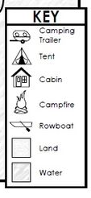 | Synchronous- Share Screen  Hook: https://www.youtube.com/watch?v=1f7ebZMLn08  Mini-lesson: After listening to Me on the Map. Discuss how a map is a bird’s eye view. Maps show basic features but not everything.  Show students different perspectives of a map using google maps. Look up different addresses on google maps and show students difference between the birds eye view and the street view | Synchronous- Share Screen  Hook: Introduce this lesson by showing the students a map of the United States, as well as a globe of the world (to show where Alaska and Hawaii are in relation to where you live). Show the students where you live on the map, talk about how many other states are part of the United States. Show students that there are also other countries in the world. Tell them we will write a letter to a kindergarten class in a mystery city and state and when they write us back we will look on the map and see where they live  Minilesson: Together write the class in another city and state a letter as a class:  Dear Kindergarten Class,  We are kindergarten students at ____________________. There are _______ (number of) students in my kindergarten class. Our school is in Sandy Springs, Georgia about 15 miles from Georgia’s capital city Atlanta. Atlanta is where Martin Luther King, Jr. was born and where Coca Cola was invented.  My class will find your city and state on the United States map. I hope to hear from you!  Sincerely,  ______________________________’s Kindergarten Class  Heards Ferry Elementary School | Synchronous- Share Screen  Hook: TW show this map. TW put board on interactive pen mode so students can come up and help do the following.  Mini-Lesson:  - Label north, south, east and west on the compass rose.  - Color the water blue and the land green  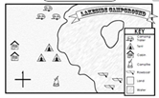 | Synchronous- Share Screen  Hook: TW show this map. TW put board on interactive pen mode so students can come up and help do the following.  Mini-Lesson:  Where are the tents related in relation to the camping trailers? Draw and arrow and use the compass rose as a resource to help you.  Where are the row boats in relation to the campfire? Draw an arrow and use the compass rose as a resource to help you.
Reader’s Workshop Mini-Lesson  12:00pm – 12:10pm | Synchronous- Share Screen  Unit 4: Bigger Books, Bigger Reading Muscles  Lesson 4 | Synchronous- Share Screen  Unit 4: Bigger Books, Bigger Reading Muscles  Lesson 5 | Synchronous- Share Screen  Unit 4: Bigger Books, Bigger Reading Muscles  Lesson 6 | Synchronous- Share Screen  Unit 4: Bigger Books, Bigger Reading Muscles  Lesson 7 | Synchronous- Share Screen  Unit 4: Bigger Books, Bigger Reading Muscles  Lesson 8
Reader’s Workshop  12:40pm – 1:25 | Synchronous- Share Screen  See column on the left for your student’s small group time to be on Teams. | Synchronous- Share Screen  See column on the left for your student’s small group time to be on Teams. | Synchronous- Share Screen  See column on the left for your student’s small group time to be on Teams. | Synchronous- Share Screen  See column on the left for your student’s small group time to be on Teams. | Synchronous- Share Screen  See column on the left for your student’s small group time to be on Teams.
Group 1 - 12:40-12:55
Group 2 - 12:55-1:10
Group 3 - 1:10-1:25

